STEPS FOR MAKING REGISTRATION FEE PAYMENT FROM HDFC ACCOUNT
- Login to your HDFC net banking account

- Go to Funds Transfer >> Transfer to eCMS Account.
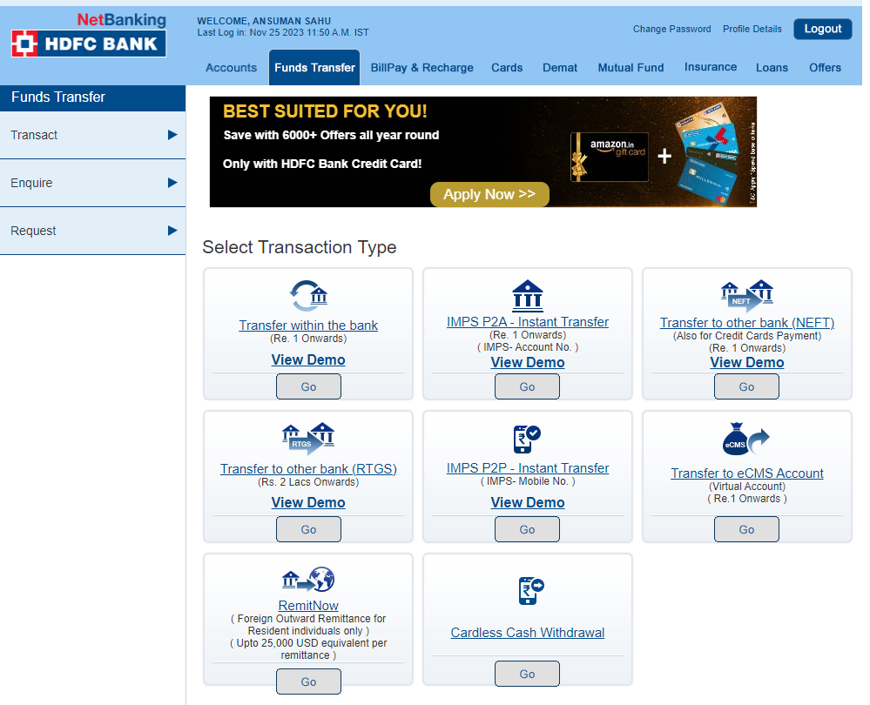

- If no beneficiary has been added earlier, a link will appear to add beneficiary. Provide the following details in the same:
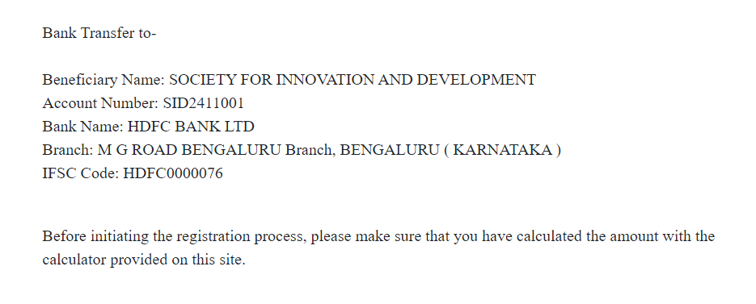
Email ID – guruprasadr@iisc.ac.in

- After 30 minutes the beneficiary will be activated. Once again go to Funds Transfer >> Transfer to eCMS Account. Select “SOCIETY FOR INNOVATION AND DEVELOPMENT” as the account to which fund is to be transferred.
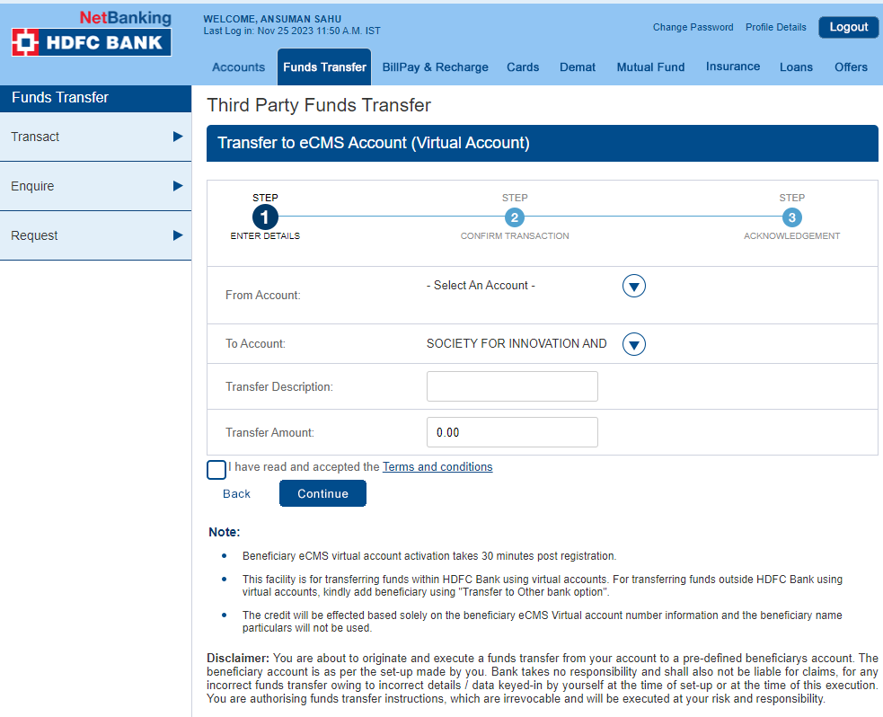
After adding as beneficiary, the account will be listed here.

